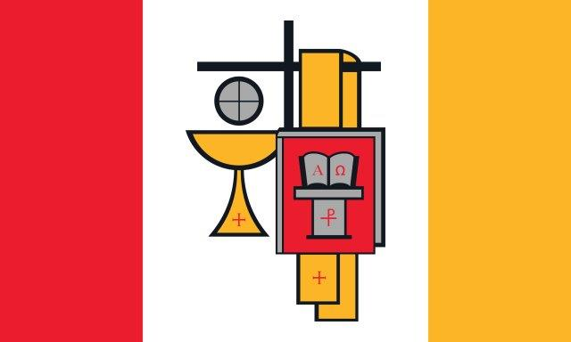

Melchizedek Village, named after the first priest mentioned in the Bible, is home
to seven retired diocesan Roman Catholic priests.

The flag of Melchizedek Village is a flag of Christ’s priesthood and a flag for ordained priests. The predominant colors are red, white and gold.

Jesus Christ is Priest, Prophet and King. Catholic priests are ordained to share in the Priesthood of Jesus Christ.

- Red represents Christ the Priest pouring out his blood on the cross of Calvary and on the altar of Eucharist. It is the color of His sacrifice, which brings reconciliation and freedom.
- White represents Christ the Prophet purifying everything by his words and his miracles. It is the color of His truth, which brings gratitude and hope.
- Gold represents Christ the King putting everything in right and proper order according to God’s original design. It is the color of His kingdom, which brings victory and justice.
- The chalice and host, the book and the stole are signs of the priesthood.

Sharing in the priesthood of Christ, a priest is ordained for a ministry of sacraments and service, preaching and teaching, and leadership and presence. The three-part ministry of the priest is reflected in the colors of the flag: presiding (red), preaching (white) and presence (gold).

The “alpha” and “omega” – the first and last letters of the Greek alphabet, meaning that Jesus is the beginning and the end of all things – and the “chi” and the “roh” superimposed on each other – the first two letters of “Christos,” the name of Christ in Greek – indicate that the book is the Word of God, who is Jesus Christ.

The Melchizedek Village flag had its beginning in the inspiration and at the initiative of Monsignor William (Bill) Myers, a native of Dayton and a priest of the Diocese of Steubenville, who recruited the help of Father Robert (Rob) Waller, a priest of the Archdiocese of Cincinnati, in designing the flag. Both priests were residents of Melchizedek Village at the time. The design of the flag and the payment for the flag were approved by Father Eric Bowman, the pastor of Transfiguration Catholic Church, West Milton. With the assistance and urging of Mr. Dennis Hile, the business manager of the parish, the cost of the flag’s production and the planting of the flag pole was paid for by the Catherine Lange Estate of the Transfiguration Center for Spiritual Renewal. The flag was raised for the first time on Thursday, August 3, 2017, the eve of the feast of St. John Vianney, the Cure of Ars, patron saint of parish priests. At the moment of the first raising of the main flag, flags of the same kind but of a smaller size were flying on each of the ten homes of Melchizedek Village. The landscaping design and implementation was accomplished by Michael Mayor as his Eagle Scout project, under the supervision of Mr. Bob Iiames, horticulturalist at the Lange Estate.

Dedication Remarks (Father Bill Myers)

From: William Myers [mailto:bmyers1939@gmail.com]
Sent: Saturday, August 05, 2017 12:57 PM
To: Rob Waller
Subject: Flag Dedication Ceremony
On behalf of Fr. Rob Waller, who collaborated with me, and the priests who live here at Melchizedek Village, a warm welcome and many thanks to all of you for being here. Thanks in particular to Fr. Eric Bowman, Pastor of Transfiguration Parish, and Mr. Dennis Hile, business manager of Transfiguration.
We are very happy to have Michael Mayor and family members present, as this dedication completes his work for an Eagle Scout Award Ceremony yet to be announced.
All flags have a few important things in common. First, they COMMUNICATE. They contain meaning, expressing a message about a nation or organization, values and purpose. Secondly, they CELEBRATE/COMMEMORATE events, anniversaries, history and significant places. Thirdly, they help create COMMUNITY, the special bond that signifies what the group has in common.
With regard to this Flag, it identifies this group of priests here at the Melchizedek Village, but even more that which we have in common with all priests in this Archdiocese and around the world. Once understood and explained, it communicates Our Lord Jesus Christ as Priest, Prophet and King. This Flag, then, is used for the purpose of celebrating feasts and seasons, as well as commemorating those days in the church year which are appropriate, for example, the Solemnity of the Transfiguration, August 6, after which this center is so named. Finally, this Flag salutes the special bond of the priesthood we are privileged to share in the service of Our Lord and His Church.

 | Christ |  |  |  | Priest
Red | Priest | pouring out his blood on the cross of Calvary and on the altar of Eucharist | sacrifice | reconciliation freedom | presiding  sacraments service  (chalice/host)
White | Prophet | purifying everything by his words and his miracles | truth | gratitude  hope | preaching  preaching  teaching  (book)
Gold | King | putting everything in right and proper order according to God’s original design | kingdom | victory  justice | presence  leadership  presence  (stole)

Short Text (for back of picture card)

The flag of Melchizedek Village is a flag for ordained priests.

Jesus Christ is Priest, Prophet and King. Catholic priests are ordained to share in the life and work of Christ.

- Red: Christ the Priest pours out his blood on the cross of Calvary and on the altar of Eucharist. It is the color of His sacrifice.
- White: Christ the Prophet purifies everything by his words and his miracles. It is the color of His truth.
- Gold: Christ the King puts everything in right and proper order according to God’s original design. It is the color of His kingdom.
- The chalice and host, the book and the stole are signs of the priesthood.

The three-part ministry of the priest is reflected in the colors of the flag: presiding (red), preaching (white) and presence (gold).

Facebook posts (Father Rob Waller)
Melchizedek Village is home to seven retired diocesan priests. I refer to the “Men of Melchizedek” as “the boys.” They are (with the number of years being a priest): front row, Father Jerry Bensman (53), Father John Porter (61), Monsignor Bill Myers (48); back row, yours truly (42), Father Ken Baker (55), Father Dave Vincent (53), Father Dave Brinkmoeller (46). That is 358 years of ministry as priests.
The Melchizedek Village flag had its beginning in Father Bill Myers, a native of Dayton and a priest of the Diocese of Steubenville, who recruited my help in designing the flag. The flag was raised for the first time on Thursday, August 3, 2017. At the moment of the first raising of the main flag, flags of the same kind but of a smaller size were flying on each of the ten homes of our Melchizedek Village.
Why a flag? (Father Rob Waller)

I just like flags. I like rainbows and marching bands, too. There is something about a splash of color and movement that is fun.

Countries have flags, schools have flags. Flags are about being together, about purpose, about goals. Sports teams have those huge flags. Somebody runs around the field, and the fans cheer. So, why not a flag for priests?

Certainly this flag is for this little community of ten homes where we live. It is the flag of Melchizedek Village. But more, it is a flag about Christ and about priesthood; it is a flag for all priests. It is about the unity and community that we have, and about the work and the hope that we share, under the banner of Christ.

And besides, it is colorful, and it flies in the wind. It’s just fun!

